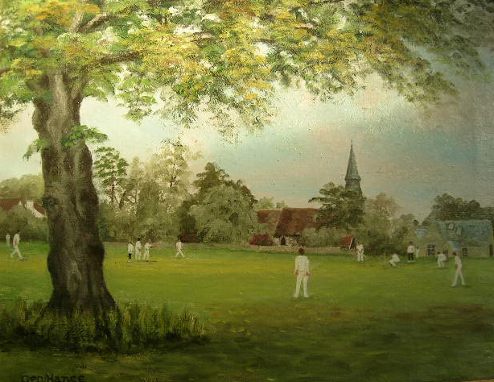

Cricket on Chorleywood Common

Cricket has been played on Chorleywood Common for nearly 200 years. The Cricket Club believes that most residents of Chorleywood would wish this to continue. Not only does it form an intrinsic part of the character of the village, but it is very much a shop window for all who approach Chorleywood along the main road. Happily, cricket continues to thrive, not only through five senior sides, but importantly, through the seven youth teams which play and practise there during the summer season.

However, the Cricket Club has now reached a critical point in its life where two main issues need urgent attention:
1. Balls bouncing and flying into the road causing risks of personal injury and/or vehicle damage with consequential third party claims against the Club. This is an increasing problem because of the road becoming busier in recent years.
2. There is a need for a new pavilion -- the present ‘temporary’ building was erected over 40 years ago and is well past its sell-by date.
It would be irresponsible to replace the present pavilion until the road problem is resolved. These problems need to be dealt with in tandem. If this does not happen, the Club’s continued presence on the Common is in jeopardy. Assuming a satisfactory solution to the road problem is found, the Club then will be in a position to proceed with the construction of a new pavilion. This clearly will be an expensive operation and we would hope to obtain some financial help from outside bodies, although a substantial amount would have to be found locally.
The present temporary low barrier provided by the Parish Council is reducing the number of balls rolling into the road and provides additional safety for the substantial number of children now playing cricket on the Common. It does not however, provide a barrier for a significant number of bouncing and high hit balls landing in the road. As a consequence, the Parish Council and Cricket Club intend to work together with others to find a satisfactory overall solution. It is hoped to come up with a scheme that has support from all interested parties, including the residents of Chorleywood, for implementation at the end of the 2008 cricket season. Undoubtedly, proposals are going to require some major changes around the area of the cricket field. Issues such as the position of the horse track, some trees and some acid grassland will have to be considered. Arriving at a satisfactory solution will take time, especially when one considers that there are many people to be consulted. This includes the Commoners, the Friends of the Common, Three Rivers District Council, Countryside Management Services and the Department of Food and Rural Affairs.
The Club wishes very much to continue playing on its historical site, as we believe cricket on the Common at Chorleywood is part of our local heritage. We hope that everybody feels the same way. Any moral support that you are able to give towards backing the search for an acceptable solution would be very much appreciated. Letters to the Secretary of Chorleywood Cricket Club expressing your views would be very helpful.
Please write to Owen Edis, 17 Greenbury Close, Chorleywood, Herts WD3 5QT
Denys Downing – President, Chorleywood Cricket Club July 2007

