Here’s how it works…  - We will be showing eight films of actual horse races throughout the evening, each with eight numbered horses.  - Place a bet at the tote table on whichever horse you think will win the race.  - You can bet on as many horses as you like, as many times as you like.  - You will be given a ticket for each bet. Hold on to this, you’ll need it to claim your winnings.  - When all bets have been placed, the race will be shown and the winner displayed.  - If your horse is the winner, collect your winnings from the tote table.    www.racenight.co.uk |  | 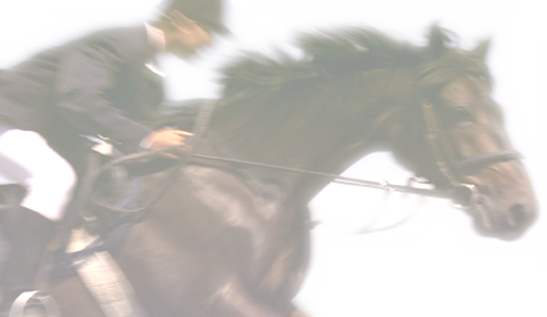
  WELCOME TO THE
  CHORLEYWOOD RACENIGHT
  Race Evening 2008
  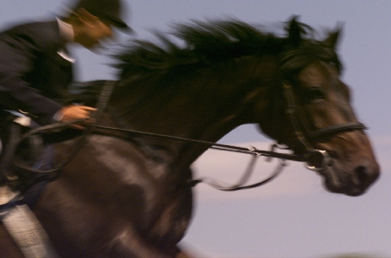
  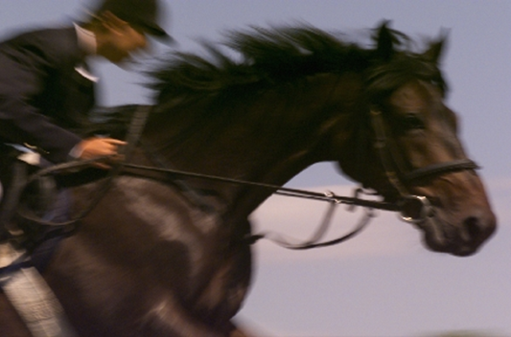
  Saturday 12th April 2008
  At Rickmansworth Park School

Race 1 The Chairmans National Owner  - Lets Get Organised by Owen Edis  8.  Race 2 Dareys Gold Cup Owner  - I bought another horse by Gill Rose  - Simon’s Umpire by Mendo  - Teacher’s Delight by Rosie  - Watford till I die by John Marchant  - Football widow by Jane Marchant  - 7000 runs by Simon Dare  - Mr Commentator by George Dare  - The Moonwalk again by Patti  Race 3 The Colts Classic Cup Owner  - Golden Duck by Lyndon Ryan  - New Gloves by Freddie Dare  - Talkative by Tom Smithson  - Short and Quick by Pete Dunning  - Gorgeous Blonde by Ashley Harris  - Mini Chorleywood Idol by Clare Smithson  - Young and Beautiful by Harriet  - Early Riser by Matt Rose  Race 4 The Rothband Chase Owner |  | Race 5 Owner  Race 6 Owner  Race 7 Owner  Race 8  AUCTION RACE  HORSES TO BE SOLD ON THE NIGHT

