Here’s how it works…  - We will be showing eight films of actual horse races throughout the evening, each with eight numbered horses.  - Place a bet at the tote table on whichever horse you think will win the race.  - You can bet on as many horses as you like, as many times as you like.  - You will be given a ticket for each bet. Hold on to this, you’ll need it to claim your winnings.  - When all bets have been placed, the race will be shown and the winner displayed.  - If your horse is the winner, collect your winnings from the tote table.    www.racenight.co.uk |  | 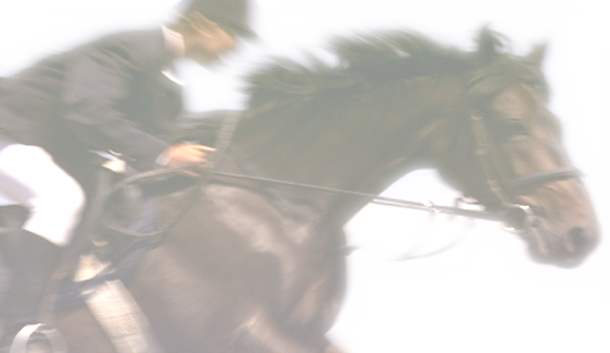
  WELCOME TO THE
  CHORLEYWOOD RACENIGHT
  Race Evening 2009
  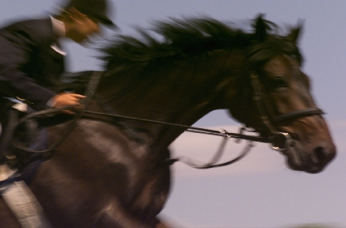
  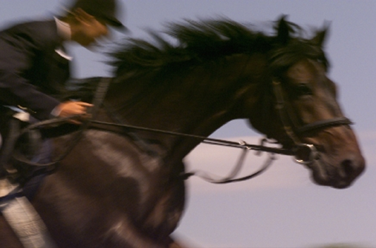
  Friday 19th June 2009
  At Chorleywood CC

Race 1 Under 11 Colts Chase / Jerry West  - The Welsh Wizard Brabs  - Bobbys Dazzler Bobby Dua  - The South American Dreamer Will Pendred  - The Badger mobile Richard and Nicola  - Broken Knees Ben Brookes  - Flighty Flossie The Jenkins  - Orange County Howard Brown  - That Horse Daniel Waistell  Race 2 Riceys Virgin Filley Chase /Nick Rice  - Tonkas 14 Nig Tyler  - Hard hitting Vikash Vikash Patel  - Salty Dog Babs  - Coachmans Lob Patrick Ryan  - Bounding Barnes The Jenkins  - Fred Mark Bryden  - Traceys Special Howard Brown  - Chunky One for Duncan Watson  Race 3 The 3.30 Chunkmeister / Duncan W  - Harrys Game Harry Collins  - Lucky 6 Charles Hardcastle  - Poor Scorer Steve Ord  - Ricolo Nicky  - President Elect Rob Dunstone  - Vital Statistics Jane Spurr  - Chairmans Delight Owen Edis  - Run Outs Ben Brooks  Race 4 Pendoggett Stakes / Tim Pendred  - Sweet pea Helen Smithson  - Demon Slayer Andy Elsmore  - HEDGETRIMMER Charlie Olley  - Who dares Wins Howard Brown  - Yarm Flyer Jon Humble  - Sams Cart Horse Sam Hatfield  - Chunky 2 for Duncan Watson  - Lucky George Simon Dare |  | Race 5 Jonny L Sprint Handicap / Jon Lyons  - Whip the Taxman Rakesh Dua  - Bit Catch Alex Hogdekinson  - Peter Terri Morbelli  - 2nd Team promotion Ben Brooks  - Fiendish Frankie The Jenkins  - Wyatt Twerp Howard Brown  - Chunky 3 for Duncan Watson  - That Other Horse Dan Waistell  Race 6 The Rolex Cup / Alex H  - Ivor the Engine Brabs  - Lucky Star Hendo  - Sat Nav Steve Dunning  - Anon Martin Tyler  - Run Machine Simon Dare  - Risky Ricky Brian Mullholland  - Owens Angels Owen Edis  - Naranja Andy Orange  Race 7 Doris Derby / Paul Downing  - Anon Again Martin Tyler  - Pinky Tea Michael Dunning  - Scorers are beautiful Jane Spurr  - MatchLess Muffin The Jenkins  - Chorleywood Idol Helen Smithson  - Owens Tribute Howard Brown  - Eyeore Andy Elsmore  - Pedigree Chum Jon Humble  Race 8 JJ Grand National / John Jenkins  AUCTION RACE  HORSES TO BE SOLD ON THE NIGHT

