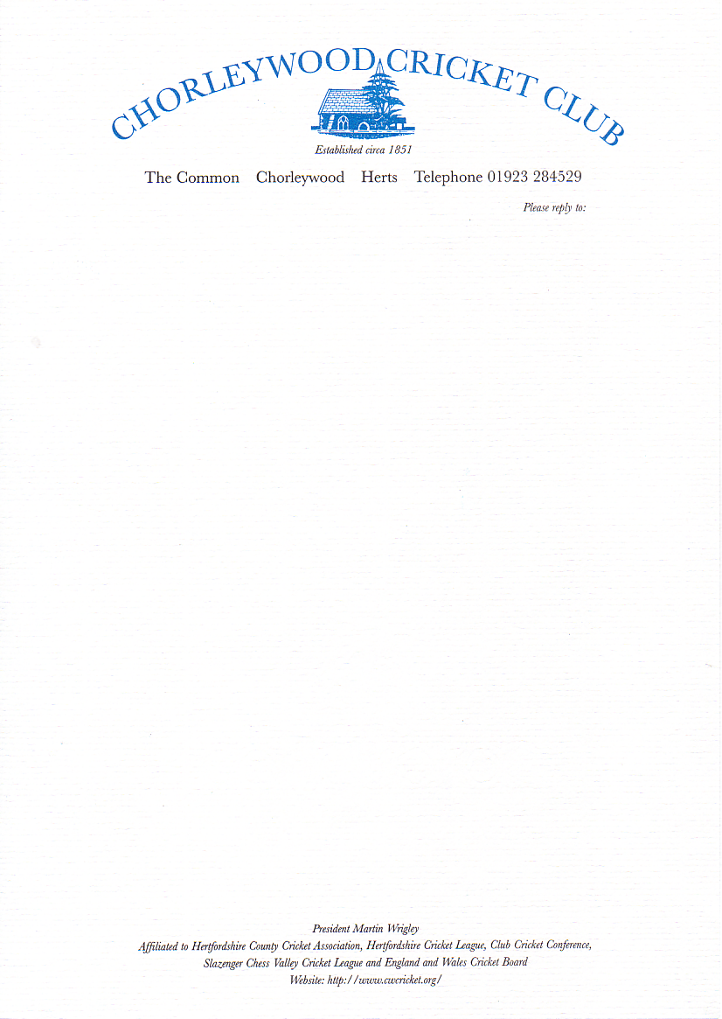

Notice is hereby given of a Special General Meeting of
Chorleywood Cricket Club

The meeting will held in the pavilion at 2000hrs on Saturday, 17th April 2004

Agenda

- Apologies for absence

- To consider and approve amendments to the Rules of the Club

- Any other business

Please will members take this opportunity to pay their 2004 subscriptions at this meeting or even before.

